**COISTE NA MÍ**

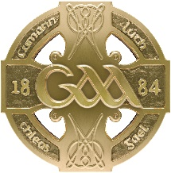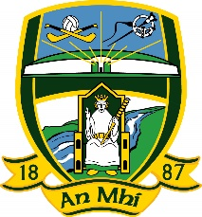

**Cumann Lúthchleas Gael**

***Cathaoirleach:***Peadair Ó h-Allúráin ***Rúnaí:***Mairead Uí Dhubhshláine

**Re: TOURNAMENTS/BLITZ GUIDELINES**

• All applications for Tournaments/Blitz to be submitted to:

o **U-14 up to Adult:** Rúnaí County Committee by the club hosting same.

o **U-12 to U-13:** Rúnaí County Committee by the club hosting same.

o **U-7 up to U-11** (Go Games): secretary.gogames.meath@gaa.ie

• Tournament/Blitz applications must be made on appropriate application form(s). All

forms available from office in Dunganny or for download from **meath.gaa.ie.**

• Fee €20 (inter club), €40 (inter county) must be included with application.

• Permission must be approved in advance by:-

o **County Committee (clubs within Meath)** ***i.e. must be sanctioned***

***at a County Committee Meeting.*** Please bear in mind when

planning your tournament that there is only **ONE** County

Committee meeting each month.

o **Leinster Council (clubs outside Meath within Leinster).**

o **Croke Park (clubs outside Leinster).**

• Tournaments/Blitz cannot commence until approval is granted in writing from CountyCommittee. Go Games tournaments/blitz must not clash with Coiste Go Games Programme or be in breach of Coiste Go Games Regulations.

* The onus is on host club to also inform Rúnaí C.C.C.C., Rúnaí Coiste Go Games,

Rúnaí Coiste na nÓg or Rúnaí Mionúir as appropriate, of the details of all games.

• ***GAMES MUST NOT INTERFERE WITH COISTE NA MI FIXTURES, which includes all grades from adult to underage in both hurling and football.***

• All tournaments to be arranged as per Rule 6.27 & 6.40 T.O. 2019.

**MAIREAD UÍ DHUBHSHLAINE**

**RÚNAÍ**