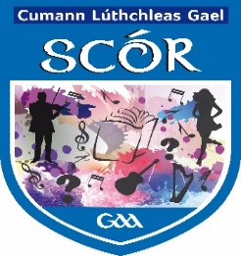

Coiste Scór na Mí

Please fill in this form and return to the Cultural Committee no later than

Wednesday 16th January 2019

meathculturalsecretary@gmail.com or irishculturalofficer.meath@gaa.ie

Quiz Registration 2019

Name of Club:

Name of Person in Charge:

Name | Address of Competitor | Competition  Under 17/over 17 | GAA Registration  Number

- I confirm that the competitors above have authorised the club to provide Meath GAA with their data for the purpose of Scór
- I confirm the above have authorised the permission of their photographs to be used for the purposes of Scór also.

Signed: Rúnai ________________ Date: __________________

