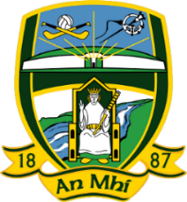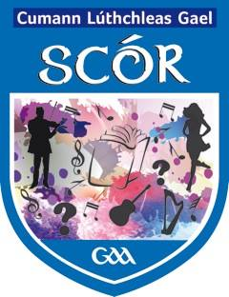**Tráth na gCeisteanna Boird 2019**

## 19th January 2019 in Navan O’Mahony’s clubhouse

* Scór na nÓg starting at 6pm sharp.
* Scór Sinsir starting at 8 pm sharp.

***All competitors taking part in the Scór na nÓg competition must be under the age of 17 on 1st January 2019***

***Signed consent forms will be required for all competitors taking part in the Scór na nÓg competition along with a GAA registration number. These are available from your club secretary***

**All competitors in Scór Sinsir must be over the age of 17 on 1 January 2019.**

**Competition details:**

* 1 team per club. Entry fee of €20 if you have not taking part in any Scór competitions this year.
* Four members on each team
* 10 rounds of 8 questions, each round will have one question ‘as Gaeilge’.
* Question categories are
  + - Gaelic and Ladies Football
    - Hurling and Camogie
    - General GAA Round
    - Irish History
    - World History and World Geography
    - Irish Geography
    - Irish Current Affairs
    - World Current Affairs
    - Irish Culture
    - General Knowledge

**Winners will represent Meath in the All Ireland finals, dates as below:**

* Scór na nÓg All Ireland finals, Castlebar, **16thFebruary 2019.**
* Scór Sinsir All Ireland finals, Castlebar, **13th April 2019.**

***Should you wish to enter a team, please contact the Coiste Cultúrtha C.L.G. na Mí on*** [***irishculturalofficer.meath@gaa.ie***](mailto:irishculturalofficer.meath@gaa.ie) ***or meathculturalsecretary@gmail.com***