**Match Regulations 2019**

**Coiste Go Games / Coiste na nÓg / Coiste Mionúir an Mhí C.L.G.**

Regulations governing the organisation and presentation of all Inter-Club Games at U7, U8, U9, U10, U11 U12, U13, U14, U15, U16 and U17 level in Meath GAA.

**Coiste Go Games / Coiste na nÓg / Coiste Mionúir are mindful of the GAA Give/Respect Get Respect campaign and have drawn up these Regulations for the benefit of all stakeholders – players, referees, team management, officials, media, members and spectators.**

**Silent Sidelines are in enforced for all games at U7, U8, U9, U10, U11, U12, U13 & U14 level.**

Details have been sent to clubs in competition regulations.

Clubs must follow rules of ‘Silent Sidelines’ when they are in force.

Anyone failing to follow these guidelines may face disciplinary action.

Penalty: Premature Termination of a Game(s); Club(s) may be removed from the competition or Go Games; Members will be dealt with under Rule 7.2 T.O. 2018. Side-line Privileges may be withdrawn from individuals in breach of Silent Sidelines.

**Sideline Official/Match Monitor** - A Sideline Official may be appointed by Coiste Go Games / Coiste na nÓg / Coiste Mionúir as appropriate and it shall be their duty to report any breaches of these Regulations.

Coiste Go Games / Coiste na nÓg / Coiste Mionúir may also appoint a Match Monitor who shall be responsible for any duties assigned. The Sideline Official shall include in their report any relevant observations or breaches reported to them by the Match Monitor. These will then form part of the

Referee’s Report in accordance with Rule 1.6, Rules of Control, T.O. 2018 Cuid II but any errors or omissions in respect of this shall not invalidate the Report as a whole.

The Meath C.C.C. may also impose penalties for breaches of the Regulations brought to its attention by members of the Meath C.C.C., Coiste Go Games / Coiste na nÓg / Coiste Mionúir or the Meath Management Committee.

Failure to respect the regulations and follow laid down procedures therein may lead to penalties as defined in General Rule & Section 3 of this document being imposed on individuals, teams, or Clubs by the Meath C.C.C.

# Ground/Pitch Regulations

**1.1** Ground Regulations shall apply to all venues. They shall include procedures for entry to each ground, designated areas for substitutes and Team Officials and shall be communicated to Teams along with the official Clár an Lae for all finals.

**1.2** The Clár an Lae shall also notify teams in advance of each final as to pre-match & halftime protocols, the assignation of dressing rooms, bib colours to be worn, etc.

**1.3** Only those players named on the Official Team list shall be allowed external entry to venue and pitch enclosure.

**1.4** A **maximum of 8** Team Officials shall be allowed entry to a venue. **All Team Officials and substitutes must stand/sit in the designated areas identified**& must leave the field of play 3minutes prior to the throw-in to go to the appropriate designated areas.

**1.5 For Go Games,** a **maximum of 2** Team Officials per team shall be allowed entry to a venue. **All Team Officials and substitutes must stand/sit in the designated areas identified**& must leave the field of play 3minutes prior to the throw-in to go to the appropriate designated areas.

**1.6** There shall be two designated areas for team personnel and officials:

1. Bainisteoir’s zone in which standing area/seats for the Bainisteoir, Maor Fóirne and a Medic should be provided (see pitch lay out on page 2);
2. A standing/seated area for substitutes and all other permitted team officials.
   1. Where the National Anthem precedes a game, Teams shall stand to attention facing theflag in a respectful manner; helmets must not be worn for Amhrán na bhFiann, for the parade or in team photographs.
   2. The team captain shall lead the parade and all players including substitutes asper official team list may march in the parade, in team jerseys & in numerical order.
   3. When requested by teams shall be provided for the official programme, and Coiste na nÓg / Coiste Mionúir will send to the media, four days before the game i.e. no later than Wednesday Noon prior to a weekend game.
   4. Players shall be numbered correctly in accordance with the Official Programme.

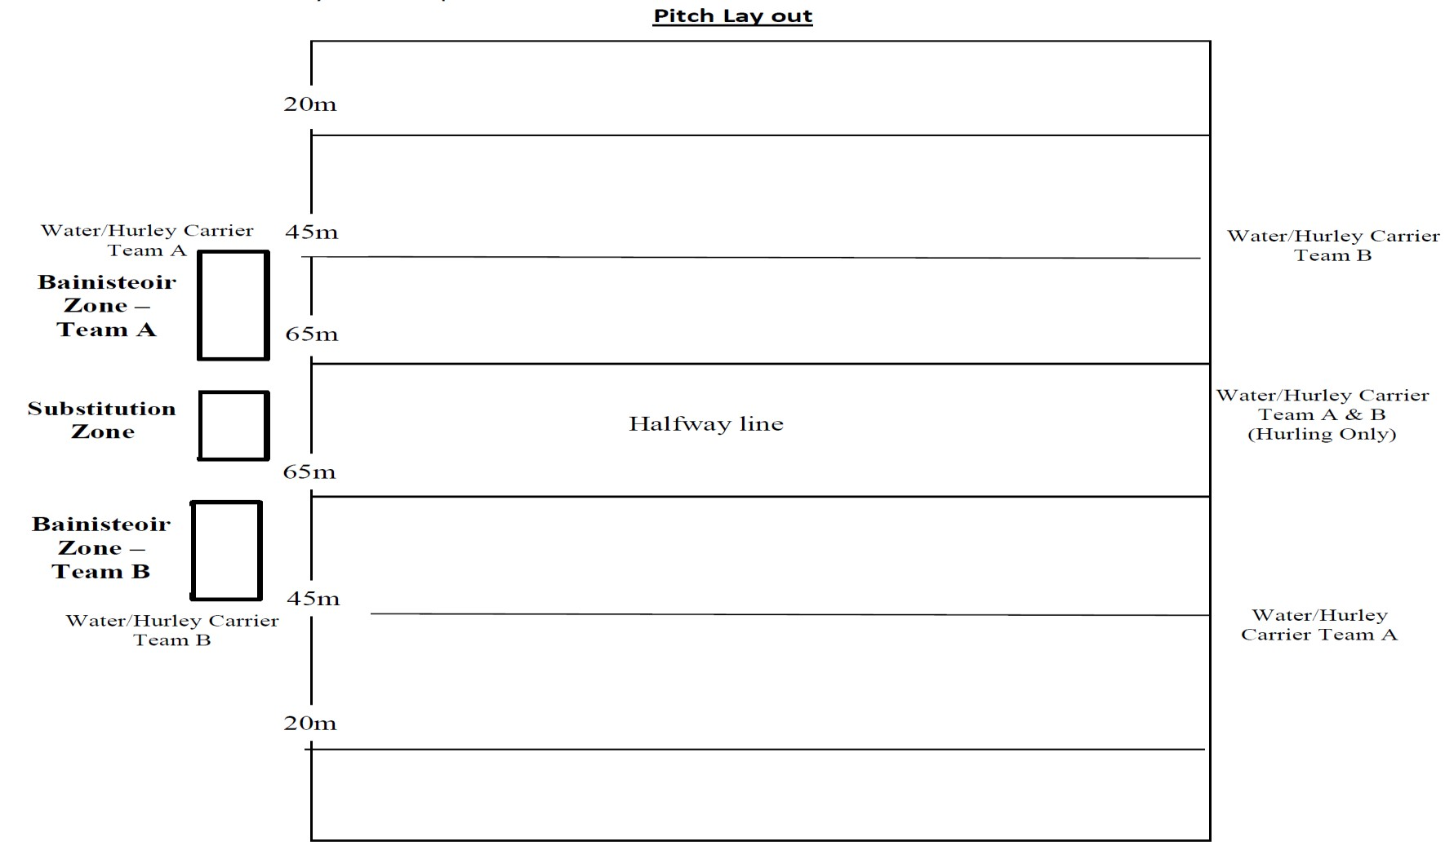

**1.11**

Ball Boys/Girls are not permitted

.

# Game Regulations

**2.1** The Referee is in overall charge of Game Regulations and shall delegate authority to theirLinesmen &

Sideline Official; They shall include the Sideline Official/Match Monitor’s report(s) with their match report as appropriate. **The Referee has the authority during the game to** **send any person in repeated breach of these Regulations to the stand/outside the pitch enclosure and such person cannot be replaced.**

**2.2** All Team Officials in the designated areas must be named on the Official list given to theReferee and should include: Bainisteoir, Maor Fóirne, Selectors, Medics, Water/Hurley Carriers, Cathaoirleach, Rúnaí & any other relevant backroom personnel.

**2.3 Cathaoirleach -** Games and Ground regulations apply to all players and officials andadherence to the regulations is the responsibility of the Club Chairperson and/or Club Juvenile Committee Chairperson. In their absence the responsibilities will pass to the Club Rúnaí/Nominated Person. The Bainisteoir also shares the responsibility of ensuring the Games Regulations are respected by players, members of team management, and supporters.

**2.4 Rúnaí -** The Club Rúnaí or Nominated Person shall relay details of substitutions to the Referee using the neutral Linesman and the SidelineOfficial when they are present.

**2.5 Bainisteoir -** The Bainisteoir shall wear a designated distinctive top and is not permittedto enter field of play. They may move along the sideline from the 65m line to the 45m line as per the “Pitch Layout” on Page 2 of these Regulations. The Bainisteoir may not act in any other capacity (e.g. as Maor Fóirne, etc).

**2.6 Maor Fóirne -** The Maor Fóirne (who must be a Selector) shall wear a designateddistinctive top and may enter the field of play **only through the area in front of the teams** **designated area**, and **only when the ball has gone out of play following a score, wide or during a stoppage called by the Referee***.*They shall exit the field at the nearest point andreturn to their designated area without interfering with play or opposition personnel. The Maor Fóirne must not be a listed member of the team panel and may not act as a designated Water Carrier/Hurley Carrier.

**2.7 Selectors -** Selectors must stand/sit in their designated area and may not act as Water/HurleyCarriers.

**2.8 Medics -** Two (2) Medical personnel shall be identified on the Official Team list and shallstand/sit in the areas designated in Ground Regulations; they shall wear clear identification and may only enter field of play to attend to injured player(s). If clubs have no medical personnel, then one member of the management who is trained in First Aid can attend to the player. This person must identify themselves to the referee prior to the game.

**2.9 Maoir Uisce** - Two Maoir Uisce (Football) /Three Maoir Uisce (hurling) who must be over18 years of age, are permitted per team; they may **not** enter the field of play. Each must wear a designated distinctive top and will be situated as per the “Pitch Layout” on Page 2 of these Regulations, and at least two metres from the sideline. Official team personnel, substitutes, injured players or members of the extended panel may not act as Maoir Uisce. In Hurling, the Maoir Uisce will also act as Hurley Carriers & may enter the field of play with a replacement hurley when necessary.

**2.10 Substitutes -** A maximumof three substitutes wearing designated distinctive tops may warm up on sidelines at any one time on their designated half of the field. No ball playing will be allowed by substitutes during the game.

**2.11 Conduct -** Any Club Committee Official or Players whomake derogatory comments in relation to Match Officials or County Committee Officials before, during, or after a game in person or on social media may be dealt with in accordance with Riail 7.2(e) T.O. 2018. Team Official(s) or Designated Person(s) (as per the list supplied to the Match Referee prior to the game) may be subject to the withdrawal of side-line privileges for future games.

**2.12 Sliotars/Footballs -** Clubs have the responsibility to control the supply of sliotars/footballs approved byCoiste Go Games / Coiste na nÓg / Coiste Mionúir to the players. Officially licensed footballs must be used and any sliotar not officially approved and displaying the official GAA stamp shall not be used. Breaches shall be brought to the attention of the Referee. Goalkeepers are not permitted a private supply of sliotars/footballs in the goal area unless they are the official balls.

**First Touch (Size 1)** footballs & sliotars must be used in **all U7/U8 matches**.

**Quick Touch (Size 2)** footballs & sliotars must be used in **all U9/U10 matches**.

**Smart Touch (Size 3)** footballs & sliotars must be used in **all U11/U12 matches**.

**Size 4** footballs & sliotars must be used in **all U13 & U14 matches.**

**Size 5** footballs & sliotars must be used in **all U15, U16 & U17 matches.**

**2.13 Late Fielding** - A team taking the field late before a game shall be subject to thepenalties outlined in Rule 6.44(d)(i), T.O. 2018; a team responsible for a half time interval being exceeded shall be subject to penalties outlined in Rule 6.44(d)(ii)(a), T.O. 2018 and a team responsible for an interval period allowed being exceeded by more than 10 minutes shall be subject to penalties outlined in Rule 6.43(d)(ii)(b), T.O.

2018.

**2.14 Extra time** will used in all Knockout Games (Playoffs, Quarter-Finals, Semi-Finals & Finals etc.). Full details of Extra Time Phase 1, 2 & 3 are outlined in 2018 Extra Time and Finishing Games on the Day.

**2.15 Matters not provided for** – Matters not specifically provided for in these regulations shall be dealt with by the referee and the team of officials on the day, and then by the Committee-in-Charge when reported via either the Referee, Sideline Official, or Match Monitor.

# Penalties

**3.1** Penalties for breaches of Ground/Pitch/Game Regulations shall be at the discretion ofthe Meath C.C.C. These may include warnings, fines, the withdrawal of sideline privileges as outlined in Regulations 2.3 to

2.11 above or suspension of individuals as considered appropriate.

**3.2 Maximum** fines for breaches of Ground/Pitch/Game Regulations and Clár an Lae:

€300 (for each reported breach).

**3.3 Minimum** fines for breaches of Ground/Pitch/Game Regulations and Clár an Lae:

€50 (for each reported breach).

**3.4** Where **Maor Uisce** sideline privileges have been withdrawn Coiste Go Games / Coiste na nÓg / Coiste

Mionúirwill appoint Maoir Uisce on a team’s behalf.

**3.5** Where **Maor Fóirne** privileges have been withdrawn, a replacement may not bepermitted; where an individual Maor Fóirne is suspended however, a replacement is permitted to perform this role.

**3.6** Where the **Bainisteoir** sideline privileges have been withdrawn the Bainisteoir will beconfined to a designated area outside the playing enclosure as decided on by Coiste Go Games / Coiste na nÓg / Coiste Mionúir.

**3.7** The frequency and gravity of reported breaches in each game shall be considered by the Meath C.C.C. and may lead to next match penalties.

**3.8** The provisions of Riail 7.2(c) T.O. 2018 regarding Misconduct at Games by TeamOfficials shall apply.

**3.9** Individuals reported for unauthorised entry on to the field of play may be dealt withunder rule 6.44 (e)



T.O.

2018

.