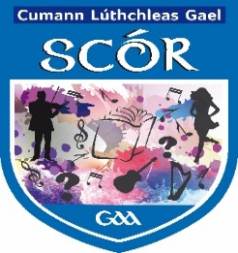

***Coiste Scór na Mí***

# Please fill in this form and return to the Cultural Committee no later than

# Friday 15th November 2019

# [meathculturalsecretary@gmail.com](mailto:meathculturalsecretary@gmail.com)

## Club Registration 2019-2020

**Name of Club:**

**Name of Person in Charge:**

|  |  |  |  |
| --- | --- | --- | --- |
| **Name** | **Address of Competitor** | **Competition** | **GAA Registration**  **Number** |
|  |  |  |  |
|  |  |  |  |
|  |  |  |  |
|  |  |  |  |
|  |  |  |  |

* **I confirm that the competitors above have authorised the club to provide Meath GAA with their data for the purpose of Scór**
* **I confirm the above have authorised the permission of their photographs to be used for the purposes of Scór also.**

**Signed: Rúnai an club ________________ Date:** __________________

**Club Secretary**